Exp. No: 18
OPTICAL SPECTRUM AND OSNR ANALYSIS USING OPTISYSTEM

OBJECTIVES
- Design an optical communication system using OptiSystem.
- Study how source power affects optical spectral intensity.
- Analyze how fiber length affects attenuation, dispersion, and nonlinear effects.
- Study the combined effect of source power and fiber length.

SOFTWARE REQUIRED
  - Optisystem

EXPERIMENT PROCEDURE
- Design the optical link in OptiSystem using laser, NRZ generator, MZ modulator, fiber and PIN photodiode
- Connect the Optical Spectrum Analyzer to observe the optical spectrum.
- Set wavelength to 1550 nm
- Vary source power and fiber length according to the test cases
- Run the simulation and record spectral power, spectral width and received power
- Compare the results for different power and fiber-length values

BLOCK DIAGRAM

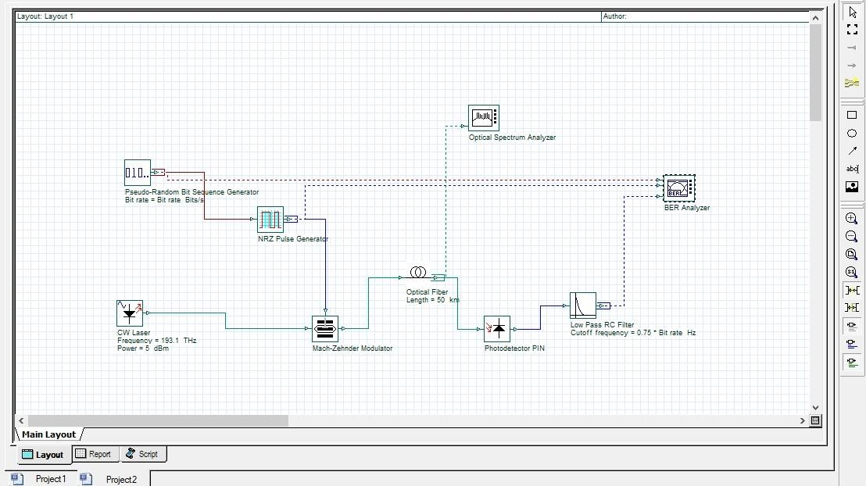

OUTPUT

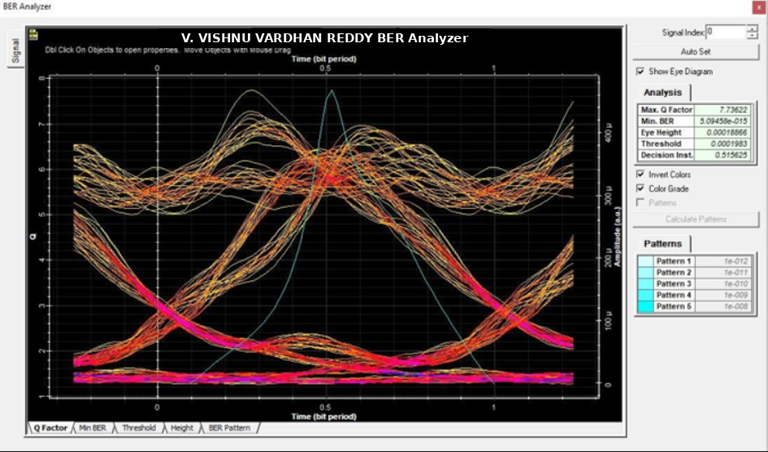

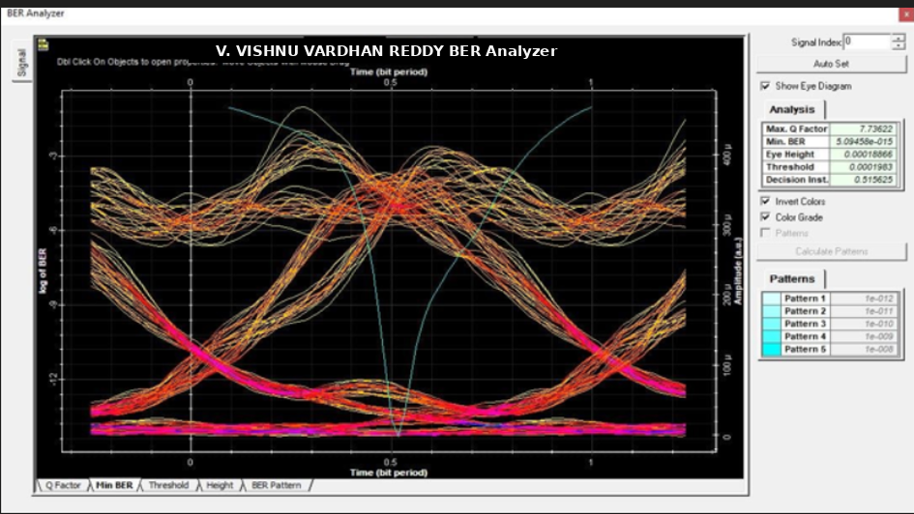

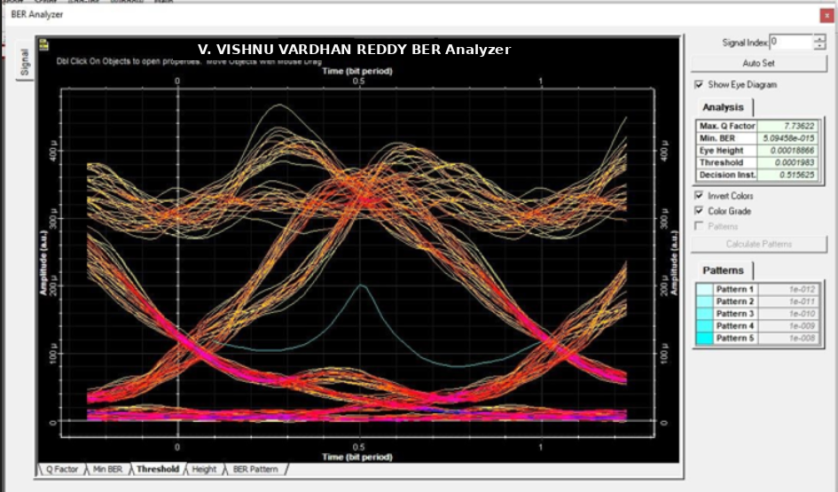
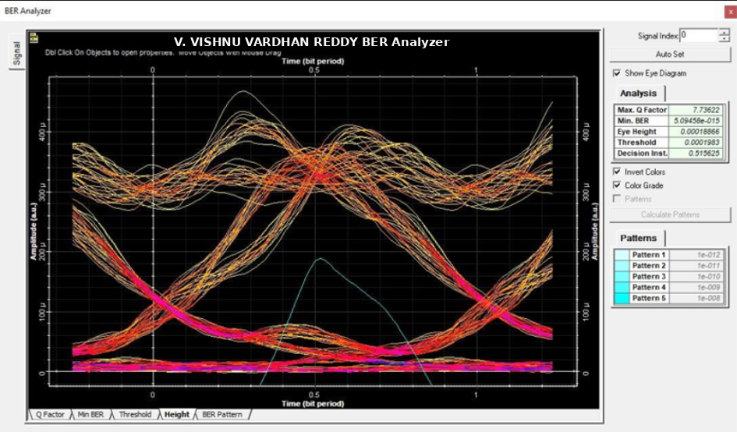

REFLECTION
- I learned how to analyze the optical spectrum using OptiSystem and observe the signal wavelengths.
- I understood the importance of Optical Signal-to-Noise Ratio (OSNR) in optical communication systems.
- I learned how noise affects the quality of the optical signal and how to measure OSNR using simulation results.
- This experiment helped me understand the relationship between optical power, noise, and signal quality in optical communication systems.

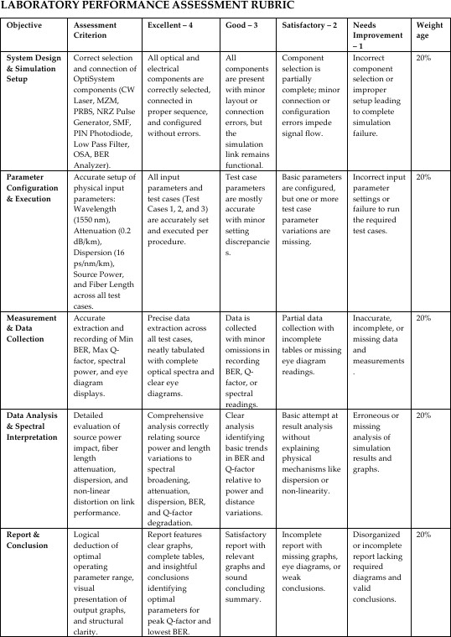

CONCLUSION
The optical spectrum was successfully analyzed using OptiSystem. Higher source power increased spectral intensity and caused nonlinear broadening, while longer fiber length led to greater a enuation and dispersion. Together, these effects increased spectral distortion and signal degradation.

